1. District 🡪 DISTRICT

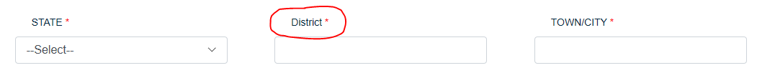

1. **Teacher's Login**

An error is generating in the following case.

For example, while registering with an email id: [madhus@avartan.in](mailto:madhus@avartan.in). It is showing the message–"School Already Exists". (1st screenshot)

But when login with the same email id, it is showing–"Invalid User". (2nd screenshot)

Kindly help.

(Note: This email id is once registered and then deleted from the 'superadmin' log.)

**(Issue Not Resolved)**

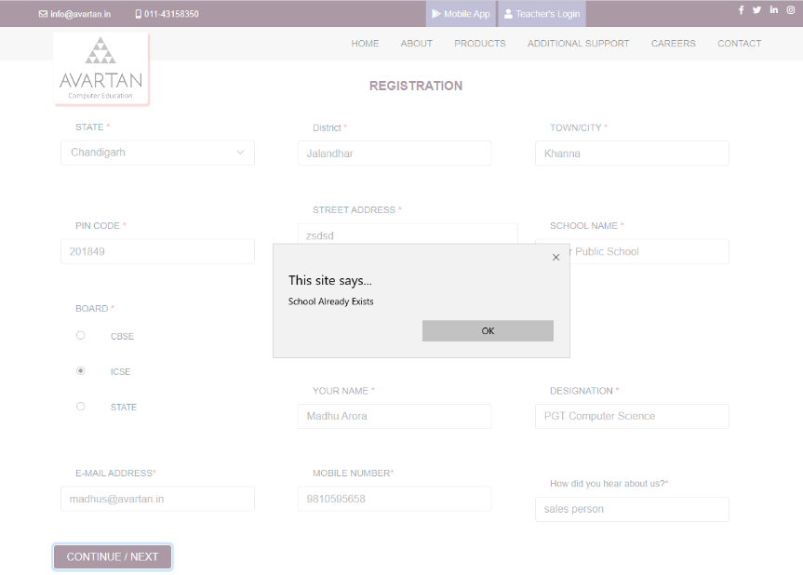

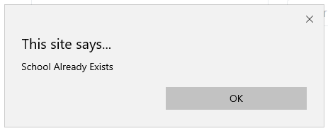

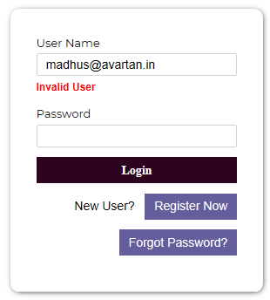

1. Notification for managing any registration requests at the admin panel.

For user panel: Updates as Notification

1. Create or Change Password Option for the User.
2. Reduce the font size of the message.

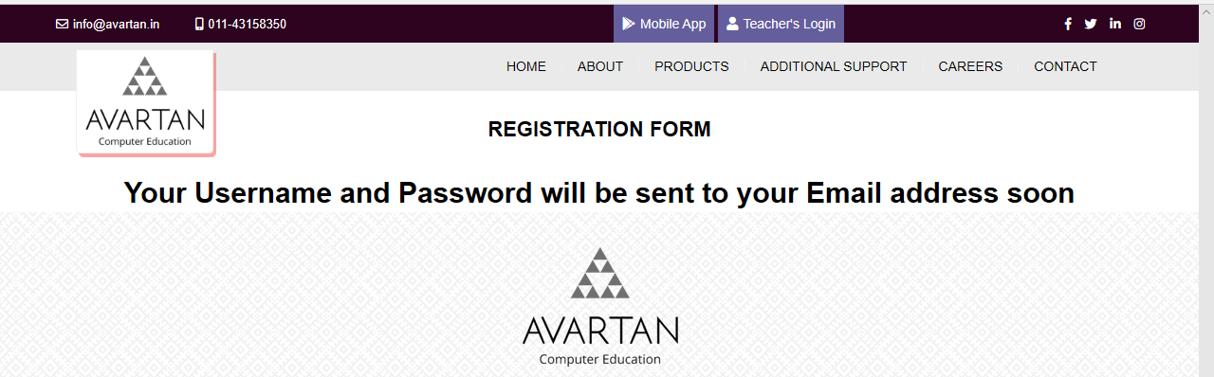

1. (**Issue Not Resolved**)

Wrong downloaded files are showing. Kindly check.

For example, if the admin has granted the permission to school 'aaaa' for Book Class 1 and 2 under the series IT Apps. (1st Screenshot)

Then, under the user mode of 'aaaa', it can download Class 1 for IT Apps and IT Beans also. (2nd Screenshot).

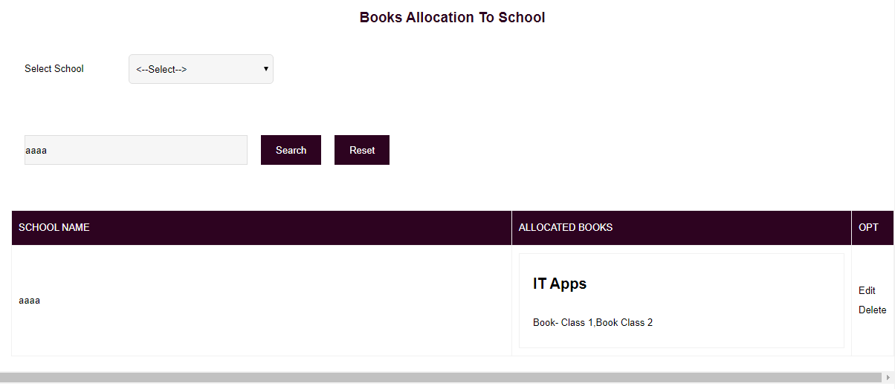

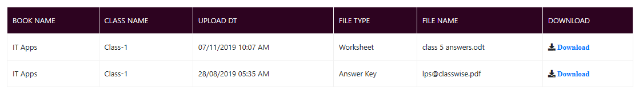

1. Displaying wrong info. Wrong allocated books are showing here. **(Issue Not Resolved)**

**Show button unavailable.**

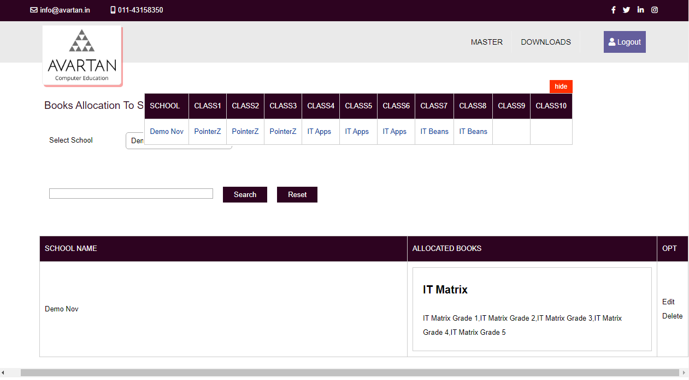

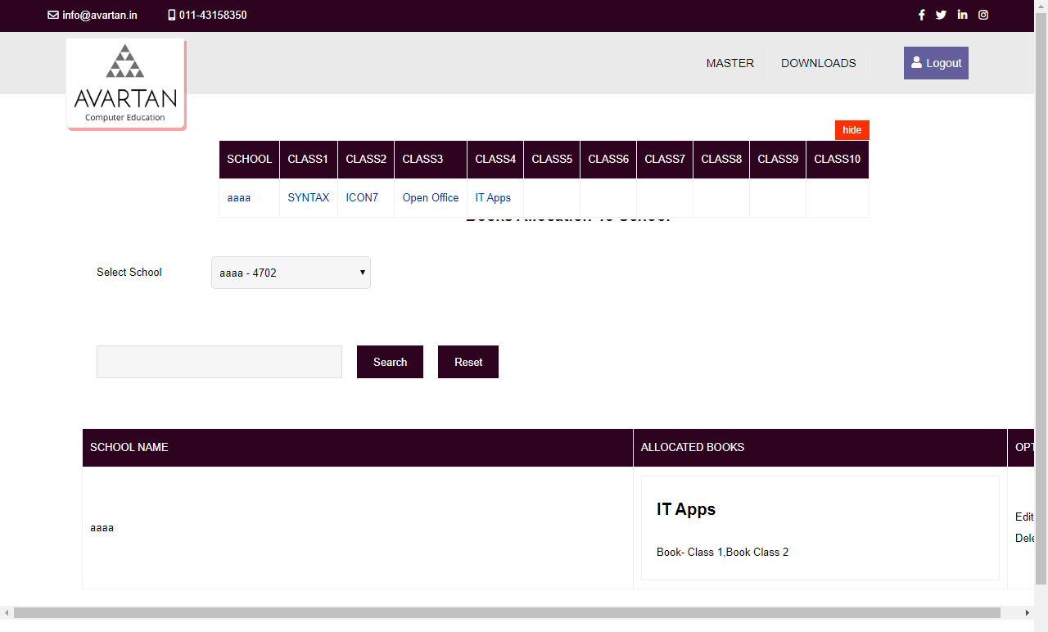

1. Kindly check the marked button.

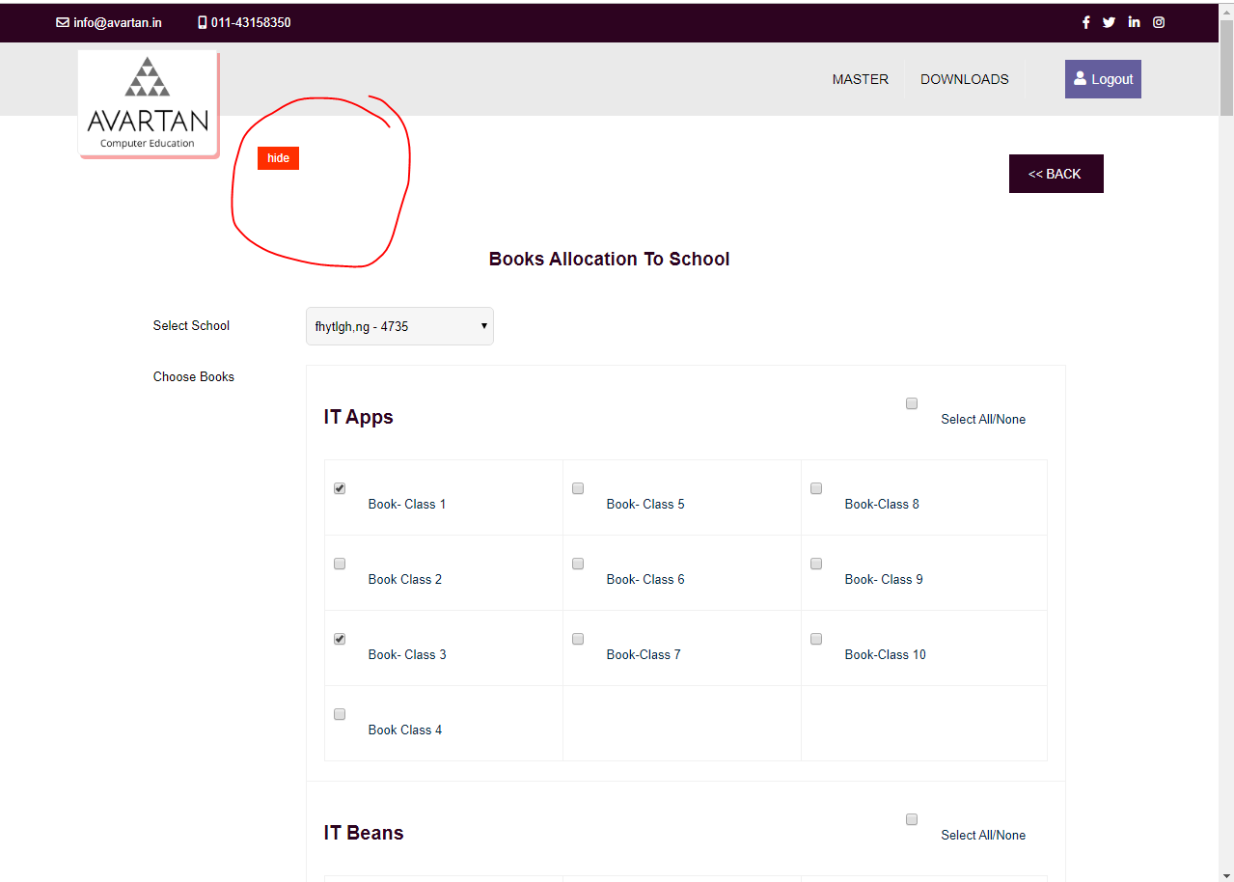

1. Use of Sub chapter’ is not clear. Kindly **Discuss.**

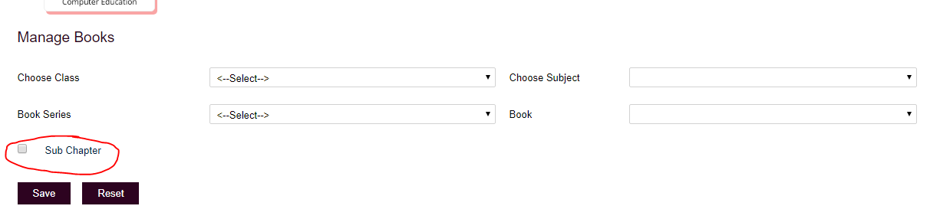

1. Horizontal Slider required: (Books Allocation to Schools)

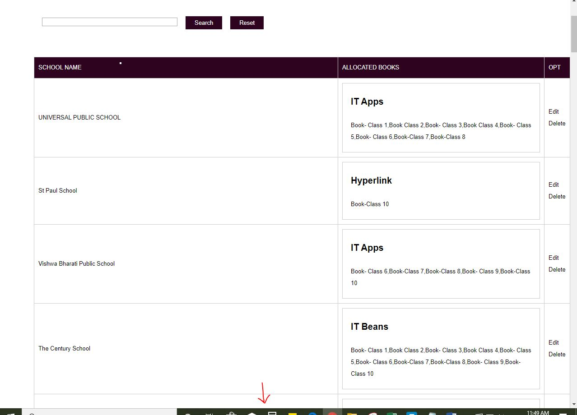

1. (**Not Resolved**)

Page numbers are not correctly displaying. Kindly check.

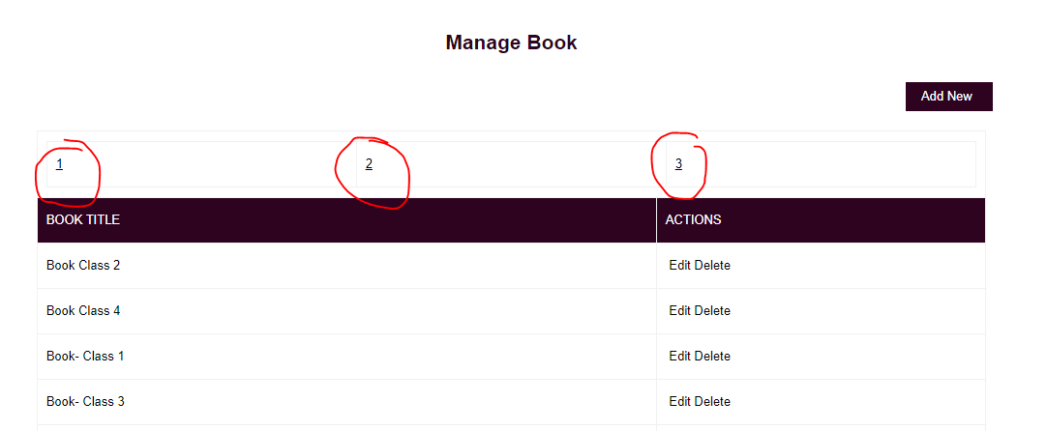

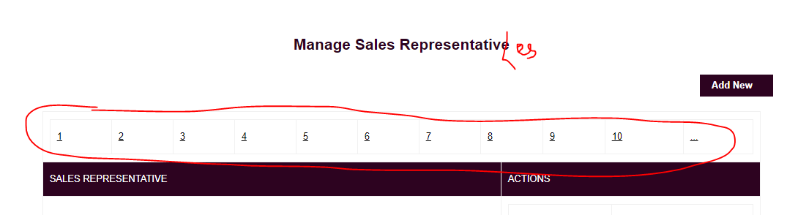

1. (**Issue Not Resolved**)

**Manage School Requests:** Add the following fields for the Admin to fill, while accepting the school request and these are mandatory to fill.

* Instead of 'Associate', use the field name 'Sales Representative'
* Type of Verification:
* School Code or MCM:

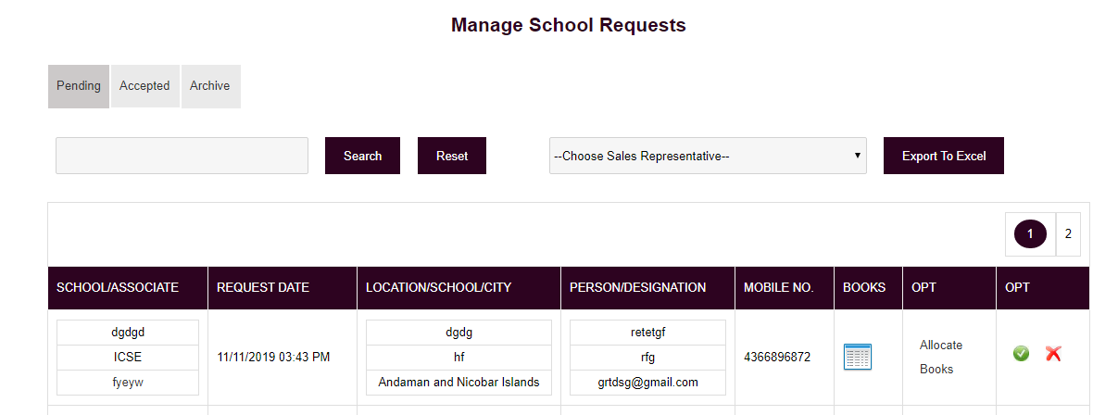

1. Correct Spellings:

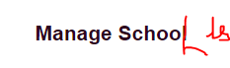

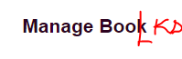







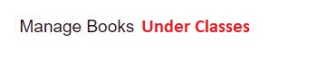

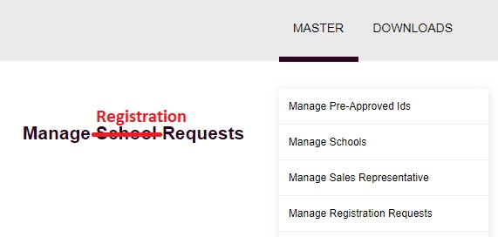

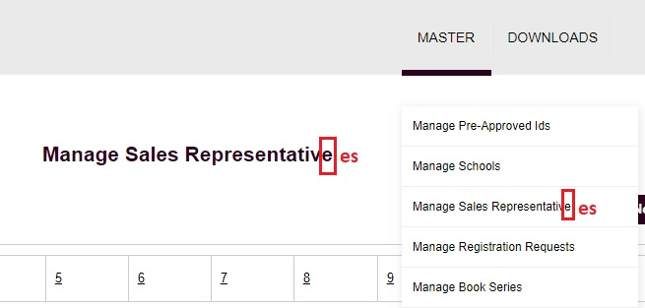

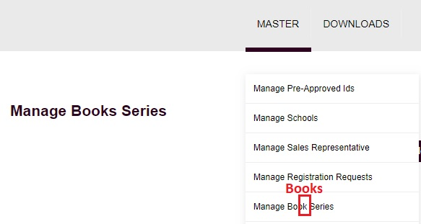

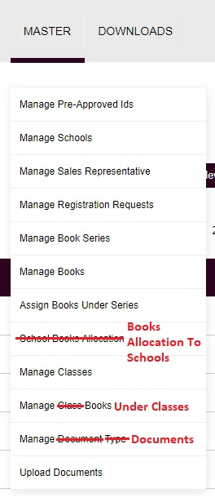

1. Make these headings similar to others.

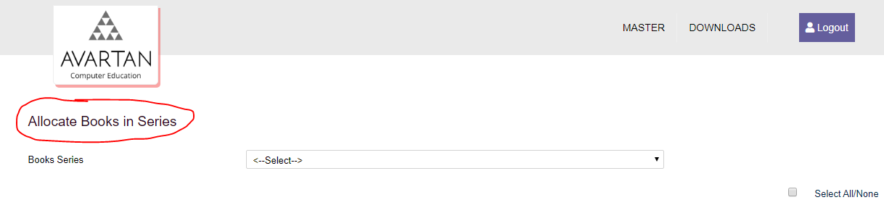

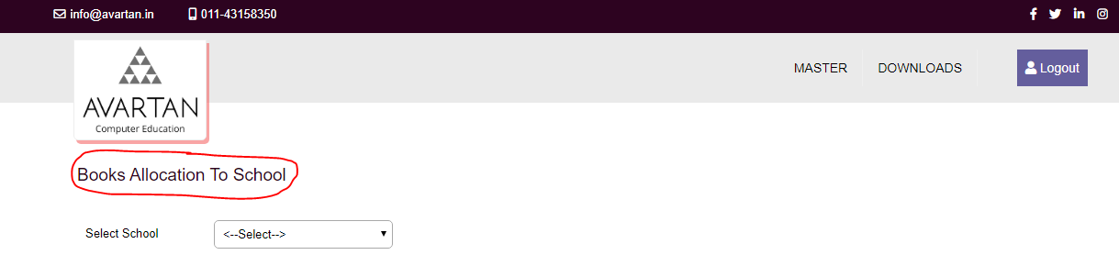

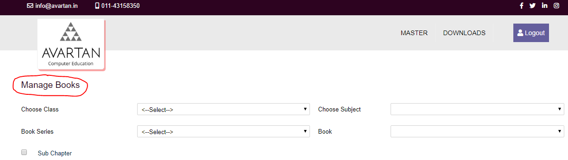

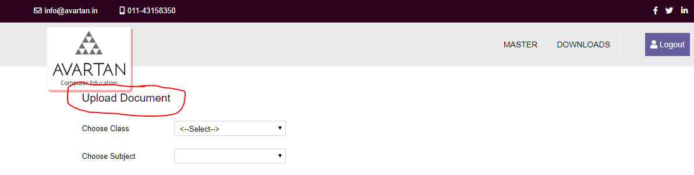

1. **Master List:** Kindly classify the list items with color groups. It will help in the understanding.

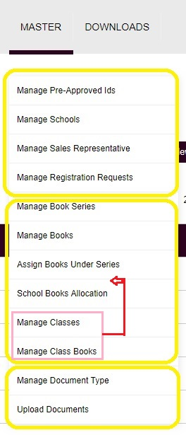

**Pre-approved Ids:**

1. Ask the User to Add email ID in the registration form.

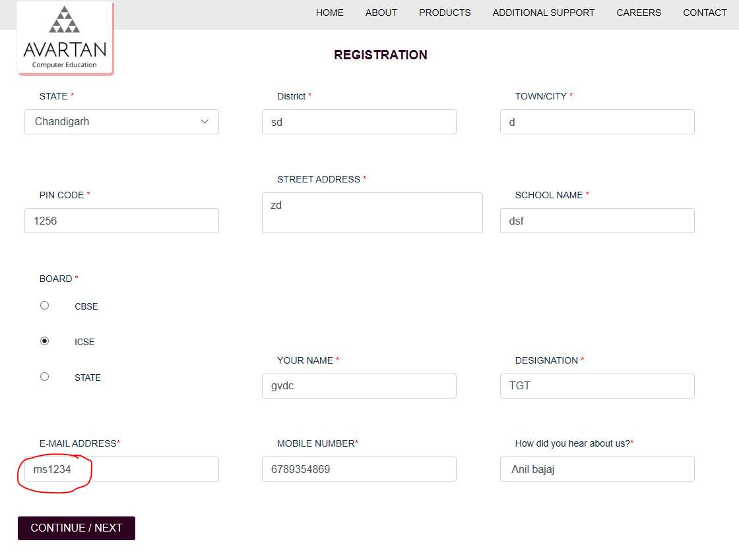

1. Kindly correct the spellings as shown below:

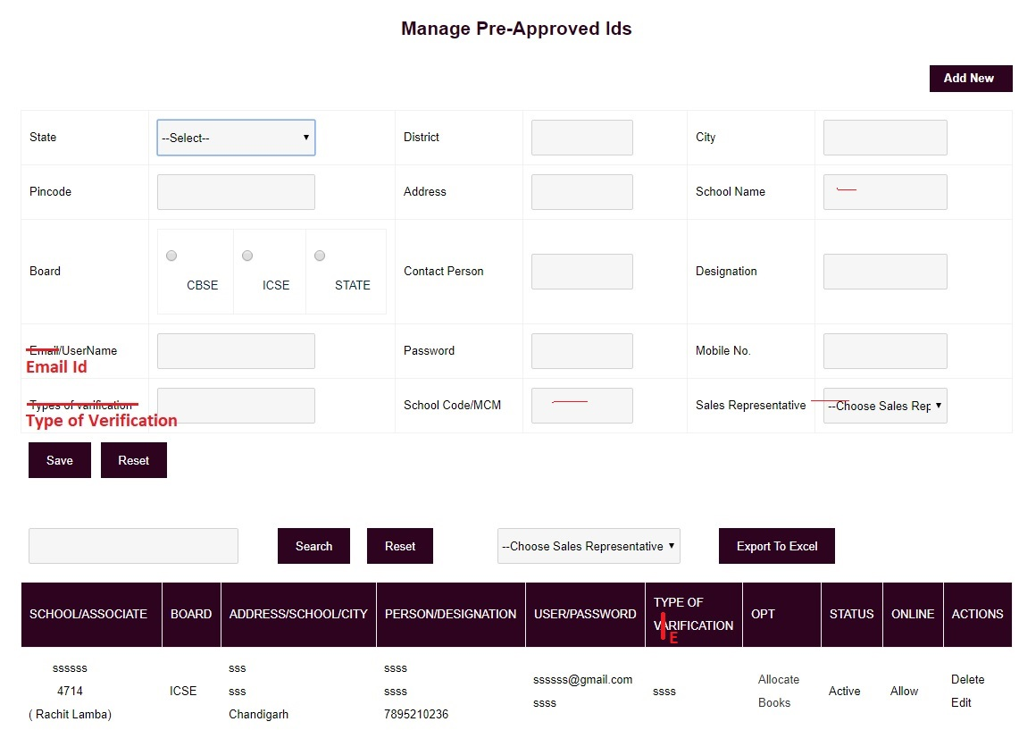

1. It should display: “School Code/MCM Already Exists”

